**Using the Playstation 3 Controller with the ESP32 Microcontroller**

The ESP-32 microcontroller has built in wireless Bluetooth capabilities. You can connect your robot to the Playstation controller to achieve remote control. Start by using the “template-ps3-controller-esp32.ino” file to confirm that your controller and ESP-32 microcontroller are properly setup, and to learn a bit about how to access data related to the controller’s buttons. A few edits will be necessary to the file, so please read the guide below, and then use the Serial Monitor feature of the Arduino IDE to verify the connection, and experiment with the buttons.

1. Install the Arduino IDE (<https://www.arduino.cc/en/software>)

Choose the download option relevant to your operating system. The Windows 10 (and 11) download is indicated above. Follow the installation directions.

1. Install the supporting library (PS3 Controller Host)
2. Install the “ESP32-WROOM-DA" Module microcontroller libraries (the red marker)
3. Plug in the ESP32. Configure the Arduino IDE Board and Port (the blue mark above)

You must configure your code to match your controller’s MAC address. This will be slightly different for each controller. Reference the number tag on your controller (or provided in the bag of provided parts) to replace the characters XX in the controller’s MAC address. Change the line “Ps3.begin("a0:5a:5b:a0:07:XX");” in the setup() function (this line is indicated in green on the picture in step 6).

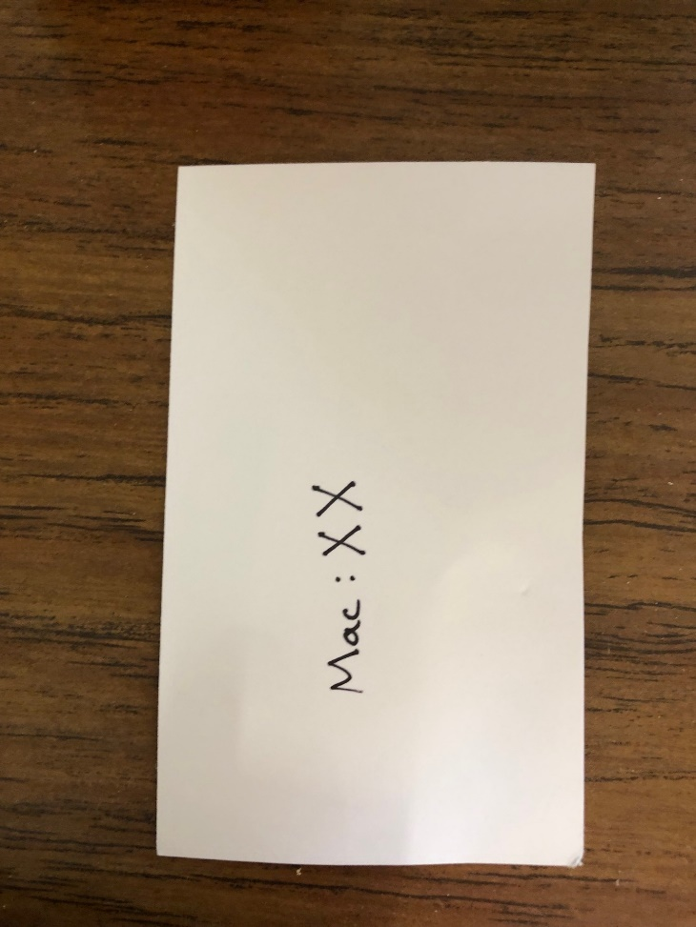

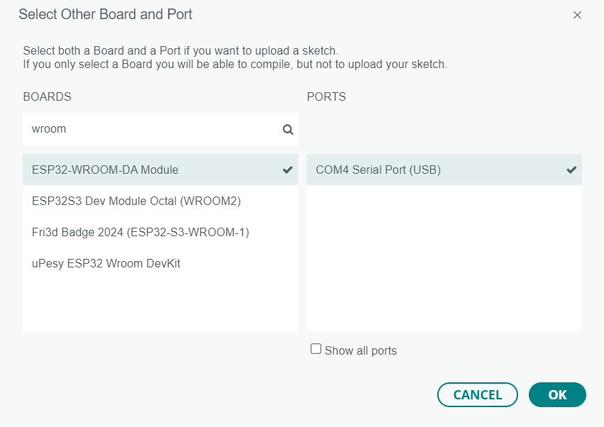

1. Compile and Upload the code to the ESP-32 (the orange marker in picture above)

ESP32 microcontrollers require holding the “Boot” button while uploading the code. Once the upload is finished (the serial monitor will indicate this, you may place the ESP32 back into Run mode by using the “Reset” button, or unplugging it and plugging it back in.

1. Open the Serial Monitor and experiment with the Playstation controller buttons

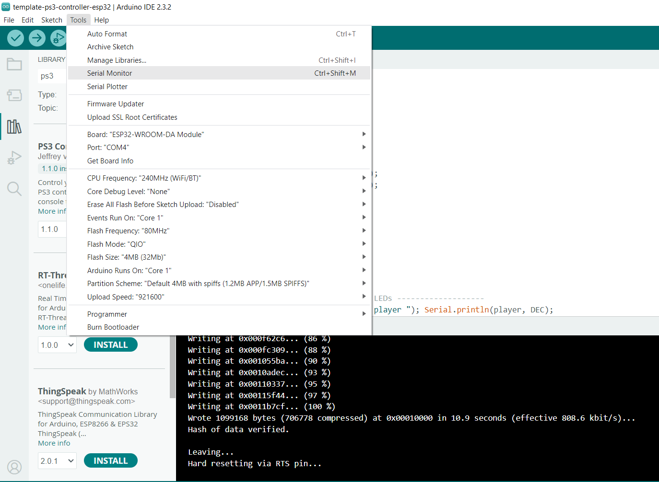

After opening the Serial Monitor, **be sure your baud rate in the code matches the settings in the Serial Monitor (see red marks below)**. The non-sensical characters indicated by the blue !!! marks are the result of a mismatch in Serial baud rates.

If you have done everything correctly, you should get output that looks something like this:

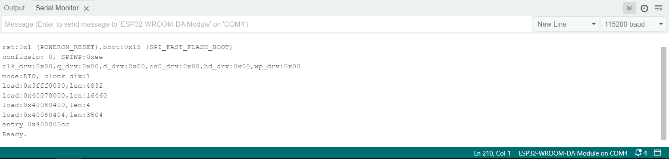

Finally, press the ‘P3’ middle button on the controller to wake it up, and the lights on the front should start flashing. The pattern will start changing every few seconds if the esp32 connected successfully to the controller.

Additional indication of which buttons you are pressing will appear in the Serial Monitor.

**Additional Information**

Further information on the ESP32 may be found at <https://www.espressif.com/sites/default/files/documentation/esp32-wroom-da_datasheet_en.pdf>

Further information on the PS3 controller library used may be found at <https://github.com/jvpernis/esp32-ps3>

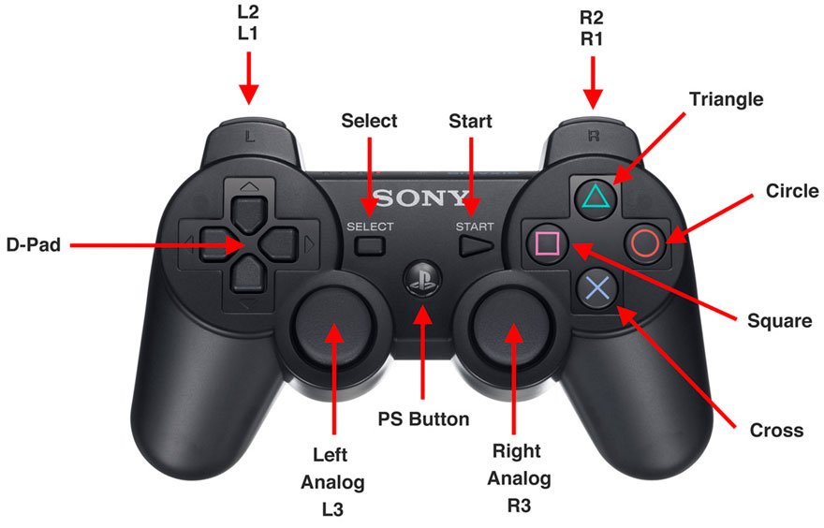

**Troubleshooting**

**If you are having trouble uploading code to your ESP32**, be sure you are holding the “Boot” button between clicking upload, and the code uploading. If this fails, try unplugging the microcontroller, then plugging it back in and clicking the upload button again. If this doesn’t work, try holding “Reset”, holding “Boot”, and releasing “Reset”. You may release the “Boot” button once upload starts (visible in Serial Monitor).

Finally, once the upload is complete, make sure you either press the “Reset” button on the ESP32 (or unplug it and plug it back in) to place the ESP32 back into the normal “run” mode.

**If you still cannot connect the controller to the ESP32**, it may be time to verify that your controller actually has the MAC address you should have in the code. Your controllers MAC address should be in the format , “Ps3.begin("a0:5a:5b:a0:07:XX");” where XX is the number on your controller or on the slip provided in your bag. Once you have set this value in the code, it is time to check the MAC address on the controller itself.

If you are sure that your controller is defective, please contact the organizers. Limited spare controllers are available, so please verify that your controller works as soon as possible.